Learning Self Monitoring
Unit 1-Global issues

Name: |  |  |  | Grade: | IVM A B  Esta guía es de autoevaluación. No tiene nota sumativa .  Solo evaluación formativa.  La fecha máxima de entrega es el día viernes 5 de junio . | Date
Puntaje Evaluación |  | 48
Puntaje obtenido:

ITEM I
Choose the best option each image( inicial-reconocer)(5 points)

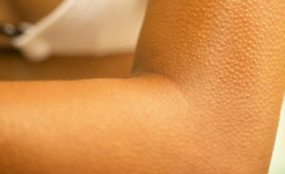
1.-
- Shaking chills
- Hen skin
- Goose bumps
- Chicken arms

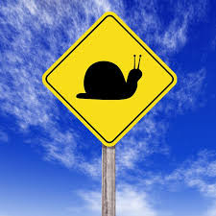
2.-
- Slow up
- Slow stop
- Slow slow
- Slow down

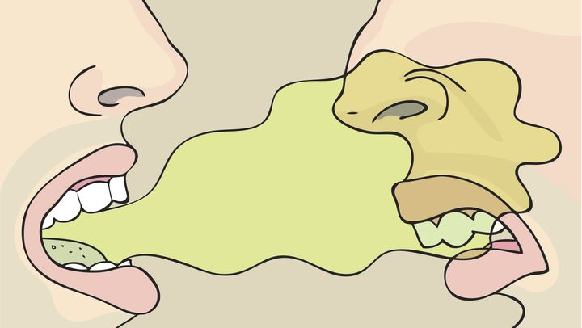
3.-
- Dirty
- Fragrance
- Odour
- Venom

4.-
- Out fill
- Fill up
- Fill out
- Fill in

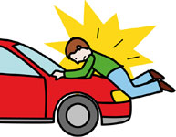
5.-
- Running up
- Run up
- Run over
- Run down

ITEM II,. Read the words and Identify the right descriptions ;(Diferenciar – intermedio)(10 points)

1.- Stereotype
- A type of appareance
- A belief about something that might not be true.
- A belief about something that might be true.
- A belief about races.

2.- Overgeneralization
- is to make an assumption that is too broad.
- A belief about something that might be true.
- A belief about something that might not be true.
- A traditional story sometimes popularly regarded as historical but not authenticated.

3.- Myth
- A modern story of obscure origin and with little or no supporting evidence that spreads spontaneously in varying forms and often has elements of humor , moralizing or horror.
- A traditional story sometimes popularly regarded as historical but not authenticated.
- is a folk genre consisting of narratives or stories that play a fundamental role in a society, such as foundational tales . The main characters are usually gods, demigods or supernatural animals.
- is to make an assumption that is too broad.

4.- Legend

- Is a folk genre consisting of narratives or stories that play a fundamental role in a society, such as foundational tales or origin myths. The main characters are usually gods, demigods or supernatural animals.
- A type of appareance
- A traditional story sometimes popularly regarded as historical but not authenticated.
- A modern story of obscure origin and with little or no supporting evidence that spreads spontaneously in varying forms and often has elements of humor , moralizing or horror.

5 .-Urban legend

- A belief about something that might not be true.
- A modern story of obscure origin and with little or no supporting evidence that spreads spontaneously in varying forms and often has elements of humor , moralizing or horror.
- A traditional story sometimes popularly regarded as historical but not authenticated.
- Is a folk genre consisting of narratives or stories that play a fundamental role in a society, such as foundational tales. The main characters are usually gods, demigods or supernatural animals.

Watch the video and answer the questions (be careful about your spelling and writing. Use full sentences; ( 33 points)Crear -Avanzado

Example: It`s about______________
I think, in my opinion, I believe.
Why/because.
I choose ....my favorite was etc.
Use connectors ; and , but ,so.

https://www.youtube.com/watch?v=QNZB1io-aHs;

1.-What Is The Video About?
___________________________________________________6 points

2.-Which One Do You Think Is The Scariest? 6 points

______________________________________________

3.-Why Kiyotaki Tunnel is special? 6 points

_________________________________________________

4.- Which Of Them Appears On The Pan`Labyrinth Movie? 6 points
__________________________________________________

5.- Choose On Of Them And write About It.(At Least 15 Words).9 points
__________________________________________________

CATEGORY | 3 | 2 | 1 | 0
Sentences & Paragraphs | Sentences and paragraphs are complete, well-constructed and of varied structure. | All sentences are complete and well-constructed (no fragments, no run-ons). Paragraphing is generally done well. | Most sentences are complete and well-constructed. Paragraphing needs some work. | Many sentence fragments or run-on sentences OR paragraphing needs lots of work.
Grammar & spelling (conventions) | Writer makes no errors in grammar or spelling. | Writer makes 1-2 errors in grammar and/or spelling. | Writer makes 3-4 errors in grammar and/or spelling | Writer makes more than 4 errors in grammar and/or spelling.
Length | The description15 or more words | The description is 8-9 words | The description is 5-7 words. | The description is less than 5 words.

